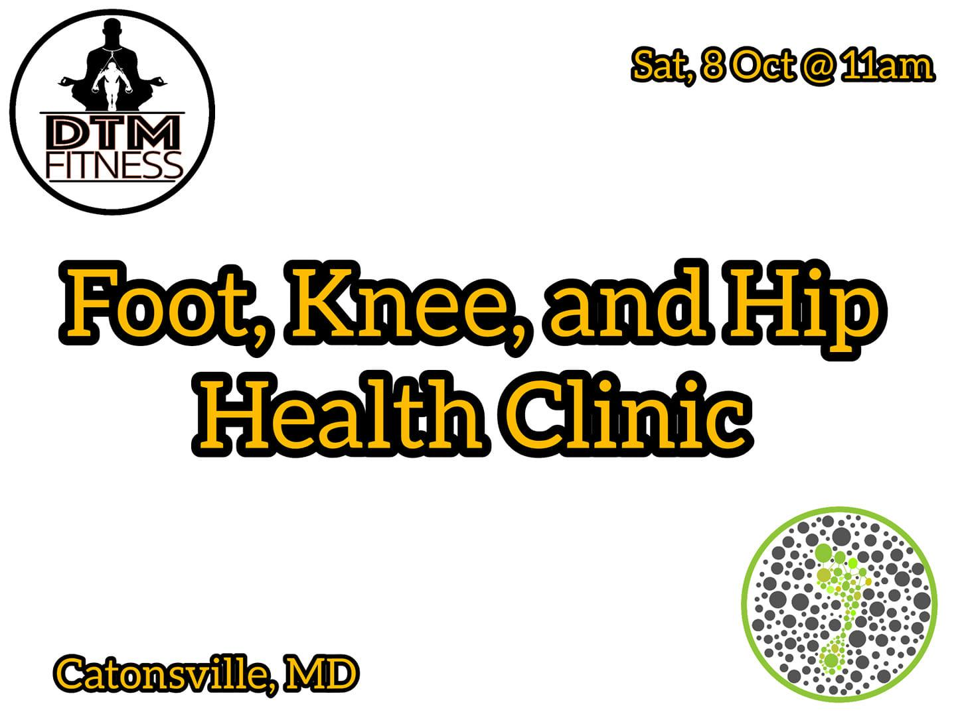

SATURDAY, OCTOBER 8, 2022 AT 10 AM – 12 PM CDT

**Foot, Knee, and Hip Workshop**

Revolve Wellness Studios

19 people responded

Event by [DTM Fitness](https://www.facebook.com/DTMFit)

[Revolve Wellness Studios](https://facebook.com/RevolveWellnessStudios)

Duration: 2 hr

Public

· Anyone on or off Facebook

Are you interested in better foot health? Would you like to learn how to mitigate back pain and hip dysfunction? Join me Saturday, Oct 8th at 11am and learn how to improve the strength and function of your feet, knees, and hips.

In this 2-hr workshop, you will be performing soft tissue therapy from your feet up to the hips. You will also learn and practice balance exercises as well hip mobility stretches.

Prepare to be barefoot (but bring your shoes)

Cost is $25 (Veterans, Teachers, and Service Industry are $10!)

Venmo @dtm-fitness (6066)

Cashapp $dtmfitness

Zelle/PayPal dtm.fitness@gmail.com

Location:

Revolve Wellness Studios

5621 Old Frederick Rd

Catonsville MD 21228

Please bring an exercise mat and water

Come hydrated!